Employees

Document Number | 1.0
Softcopy Name | <CH0101_Employees>.doc
Last Saved | January 19th, 2009
Document Classification | SRS of CheckHouse
Prepared By | Balaji.J
Reviewed By

COPYRIGHT NOTICE

Copyright © by SHLOK Information Systems India Private Limited.

All rights reserved. This material is confidential and proprietary to SHLOK Information Systems India Private Limited. and no part of this material should be reproduced, published in any form by any means, electronic or mechanical including photocopy or any information storage or retrieval system nor should the material be disclosed to third parties without the express written authorization of SHLOK Information Systems India Private Limited.

Employees 3
Module/Screen 3
Purpose: 3
Description: 3
Screen Shots 4
Screen Name (GUI Code): GUI-CH0101/OPEN 4
Screen Shots 6
Screen Name (GUI Code): GUI-CH0101/OPEN/GENDET 6
Screen Name (GUI Code): GUI-CH0101/OPEN/FILTER 8
Logical field: 9
GUI-CH0101/OPEN 9
GUI-CH0101/OPEN/GENDET 9
GUI-CH0101/OPEN/FILTER 16
Physical table: 18
Table inserted: 18
Employee 18
Screen Shots 19
Screen Name 19
GUI-CH0101/OPEN 19
CH_tblMastEmployee 19

Employees

Module/Screen

Module | Configuration – Employee
GUI Code | CH0101
GUI Name | Employees

Purpose:
This entry is used for creation and maintenance of Employee.

Description:

Screen Shots

Screen Name (GUI Code): GUI-CH0101/OPEN
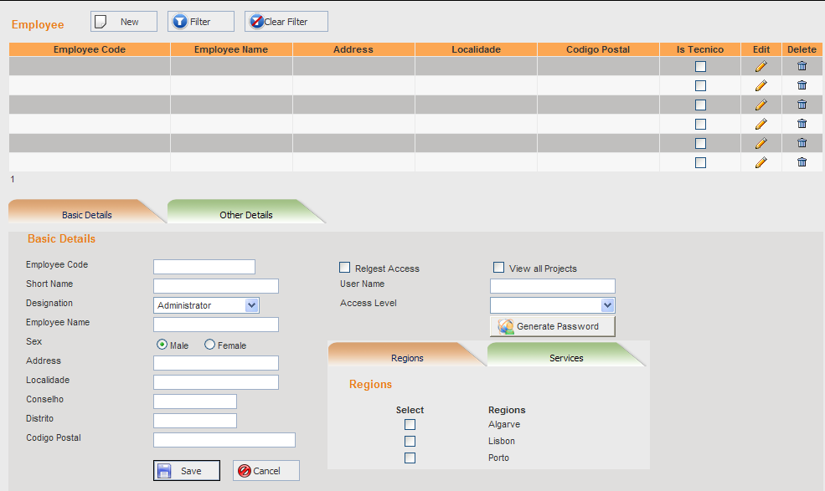
F01
The Employee grid displays the following columns:
Display Caption | Table Name | Field Name | Width | Translation Key
Employee Code | CH_tblMastEmployee | EmployeeCode | 20%
Employee Name | CH_tblMastEmployee | EmployeeName | 15%
Address | CH_tblMastEmployee | Address | 15%
Localidade | CH_tblMastEmployee | Localidade | 15%
Codigo Postal | CH_tblMastEmployee | CodigoPostal | 15%
Is Tecnico | CH_tblMastEmployee | IsTecnico | 10%
Edit | Selects the user record for editing |  | 5%
Delete | To delete the user record |  | 5%

- New – To create a new Employee.

- Filter – Displays a popup window for specifying conditions for filtering and listing the Employee records meeting those conditions. The popup window is as shown in GUI-CH0101/OPEN/FILTER.

- Clear Filter – Removes the filter conditions specified and shows all the Employee records available.

Screen Shots

Screen Name (GUI Code): GUI-CH0101/OPEN/GENDET

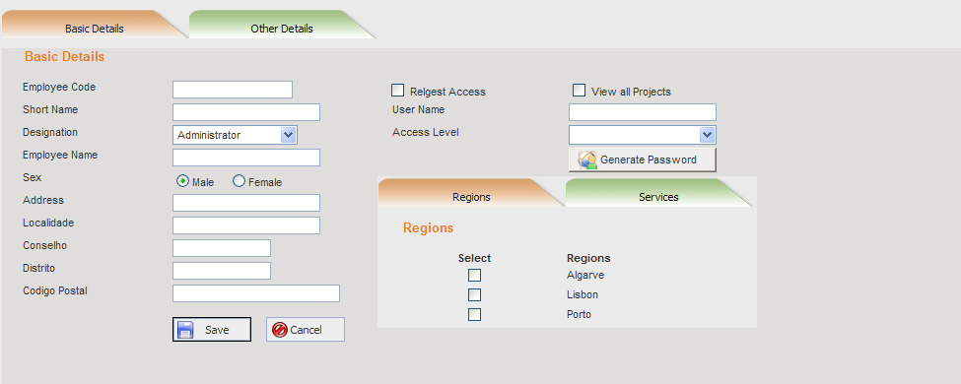
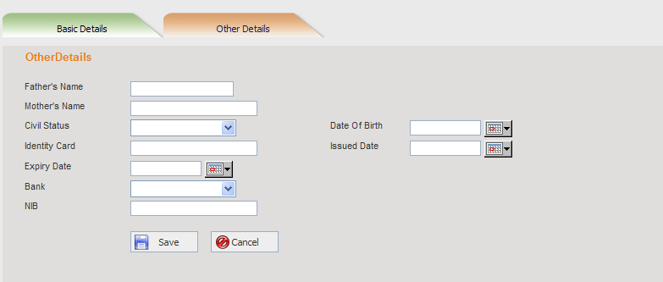

F02 & F03
(Add Mode & Edit Mode)
- Save – Confirms the changes and saves the Employee record.
- Cancel - Cancels the changes done.

UserName should be unique. Permissions to the Employee are assigned which are specific to the selected access level.
F02
(Add Mode)
The text boxes are cleared for making the new entry. When Generate Password button is clicked, a password is automatically generated for the Employee.
F03
(Edit Mode)
On clicking Edit(in the grid against a Employee record), the field values of the corresponding user record are displayed in the text/combo boxes below. The user can then edit and save.
F04
(Delete Mode)
On clicking Delete( in the grid against a Employee record) , the corresponding Employee record is deleted. If the current Employee id has any foreign key relationship, then the user record cannot be deleted.

Screen Name (GUI Code): GUI-CH0101/OPEN/FILTER

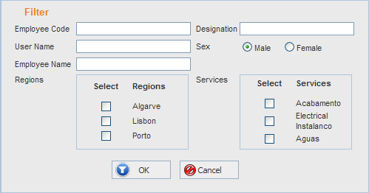
F05
The Text entered is searched for in the fields that are checked as True. Country and Language could be specified. Here the text is verified if it is available in at least one of the selected fields with or condition in combination with and condition for the combo box fields.

Search - Clicking on Search button selects the Employee records satisfying the specified conditions and fills the Employee grid with the selected records.

Logical field:

GUI-CH0101/OPEN

Logical Field | Key  (PK/FK/UK) | FKey Table Name | Description | Tab | Control Type | Enable / Disable | Default | On Change | Lookup/List | When Clause | Verify on OK
Employee |  |  |  | 0 | Grid
Basic Details |  |  |  | 1 | Tab
Other Details |  |  |  | 2 | Tab

GUI-CH0101/OPEN/GENDET

Logical Field | Key  (PK/FK/UK) | FKey Table Name | Description | Tab | Control Type | Enable / Disable | Default | On Change | Lookup/List | When Clause | Verify on OK
Employee Code | UK |  |  | 0 | Text Box |  |  |  |  |  | M, C(20)
Short Name |  |  |  | 1 | Text Box |  |  |  |  |  | M, C(50)
Designation |  |  |  | 2 | Combo Box |  |  |  |  |  | C(50)
Employee Name |  |  |  | 3 | Text Box |  |  |  |  |  | M, C(50)
Sex |  |  |  | 4 | Radio Button |  |  |  |  |  | M
Address |  |  |  | 5 | Text Box |  |  |  |  |  | C(50)
Localidade |  |  |  | 6 | Text Box |  |  |  |  |  | C(50)
Conselho |  |  |  | 7 | Text Box |  |  |  |  |  | C(50)
Distrito |  |  |  | 8 | Text Box |  |  |  |  |  | C(50)
Codigo Postal |  |  |  | 9 | Text Box |  |  |  |  |  | C(50)
RelgestAccess |  |  |  | 10 | Checkbox |  |  |  |  |  | M
UserName |  |  |  | 12 | Textbox |  |  |  |  |  | M,C(50)
AccessLevel | FK | AccessLevel | Access level for the Employee | 13 | Combo Box |  |  |  | List of Access Levels  Table: AccessLevel  Key : AccessLevelId  Description : Description | If Access is true | M, Valid Item from the list
Regions | FK | CH_tblMastregions |  |  | Tab strip Regions  Checkbox |  |  |  | List of Regions  Table: CH_tblMastregions  Key : RegionId  Description : Region Name |  | M, Valid Item from the list
Services | FK | CH_tblMastServiceType |  |  | Tab strip  Services  Checkbox |  |  |  | List Of serviceType  Table: CH_tblMastServiceType  Key:ServiceTypeid  Description :Service Type |  | M, Valid Item from the list
TechnicoType | FK | CH_tblMasttechnicotype |  |  | Tabstrip Services  Combobox |  |  |  | List Of TechnicoType  Table:CH_tblMastTechnicoType  Key :TechnicoTypeId  Description:Description |  | M, Valid Item from the list
Father’s Name |  |  |  | 1 | Tab strip  “Other Details”  Textbox |  |  |  |  |  | M,C(50)
Mother’s Name |  |  |  | 2 | Tab strip  “Other Details”  Textbox |  |  |  |  |  | M,C(50)
Civil Status | FK | CH_tblMastCivilstatus |  | 3 | Tab strip  “Other Details”  Combobox |  |  |  | List Of CivilStatus  Table: CH_tblMastCivilstatus  Key :civilstatusId  Description:Description |  | M, Valid Item from the list
Date of Birth |  |  |  | 4 | Tab strip  “Other Details”  Date Picker |  |  |  |  |  | Cannot be greater than today
Identity Card |  |  |  | 5 | Tab strip  “Other Details”  Text Box |  |  |  |  |  | M, C(20)
Issued Date |  |  |  | 6 | Tab strip  “Other Details”  Date Picker |  |  |  |  |  | Cannot be greater than today
Expiry Date |  |  |  | 7 | Tab strip  “Other Details”  Date Picker
Bank | FK | CH_tblMastBanks |  | 8 | Tab strip  “Other Details”  Combo Box |  |  |  | List of Banks  Table: CH_tblMastBanks  Key : Bankid  Description : Description |  | M, Valid Item from the list
NIB |  |  |  | 9 | Tab strip  “Other Details”  Text Box

GUI-CH0101/OPEN/FILTER

Logical Field | Key  (PK/FK/UK) | FKey Table Name | Description | Tab | Control Type | Enable / Disable | Default | On Change | Lookup/List | When Clause | Verify on OK
Employee Code |  |  | The text is searched for - in the EmployeeCode field of Employees | 0 | Textbox
Designation |  |  | The text is searched for - Designation fields of Employees | 1 | Textbox
User name |  |  | The text is searched for - in the Username field of Employees | 2 | Textbox
sex |  |  | The text is searched for - in the Sex field of Employees | 3 | Textbox
Employee Name |  |  | The text is searched for - in the EmployeeName field of Employees | 4 | Textbox
Regions | FK | Regions |  | 8 | Check box  List |  |  |  | List of Regions  Table: CH_tblMastRegions  Key : Regionid  Description : description
Services | FK | Services |  | 9 | Check box list |  |  |  | List of Services  Table: CH_tblMastServicetype  Key : ServicetypeId  Description : Description

Physical table:

Table inserted:

Employee

Field Name | Data Type | LEN | M | U | Description | Key | Reference Table | Source Screen/Tab | Source  Lbl. Name
EmployeeId | Int | 4 | Y | Y | Automatic generation | PK
EmployeeCode | Bigint | 20 | Y | Y |  |  |  | CH0101/OPEN | EmployeeCode
ShortName | varchar | 50 | Y |  |  |  |  | CH0101/OPEN | ShortName
Designation | Varchar | 50 | Y |  |  |  |  | CH0101/OPEN | Designation
EmployeeName | Varchar | 50 | Y |  |  |  |  | CH0101/OPEN | EmployeeName
Sex | Varchar | 10 |  |  |  |  |  | CH0101/OPEN | Sex
Address | Varchar | 50 | Y |  |  |  |  | CH0101/OPEN | Address
Localidade | Varchar | 50 |  |  |  |  |  | CH0101/OPEN | Localidade
Conselho | Varchar | 50 |  |  |  |  |  | CH0101/OPEN | Conselho
Distrito | varchar | 50 |  |  |  |  |  | CH0101/OPEN | Distrito
CodigoPostal | Varchar | 50 |  |  |  |  |  | CH0101/OPEN | CodigoPostal
RelgestAccess | Bit |  |  |  |  |  |  | CH0101/OPEN | RelgestAccess
UserName | Varchar | 50 |  |  |  |  |  | CH0101/OPEN | UserName
AccessLevelId | int | 4 |  |  |  | FK | AccessLevel | CH0101/OPEN | AcessLevel
FathersName | Varchar | 50 |  |  |  |  |  | CH0101/OPEN | FathersName
MothersName | Varchar | 50 | Y |  |  |  |  | CH0101/OPEN | MothersName
CivilStatusID | Int | 4 |  |  |  | FK | CH_tblMastCivilStatus | CH0101/OPEN | CivilStatus
DateOfBirth | Datetime | 8 | Y |  |  |  |  | CH0101/OPEN | DateofBirth
IdentityCard | Datetime | 8 |  |  |  |  |  | CH0101/OPEN | IdentityCard
IssuedDate | Datetime | 8 |  |  |  |  |  | CH0101/OPEN | IssuedDate
ExpiryDate | Datetime | 8 |  |  |  |  |  | CH0101/OPEN | ExpiryDate
BankId | Int | 4 | Y |  |  | FK | CH_tblMastBanks | CH0101/OPEN | Banks
NIB | Varchar | 50 |  |  |  |  |  | CH0101/OPEN | NIB

Screen Shots

Screen Name | Table Name | Type of effect
GUI-CH0101/OPEN | CH_tblMastEmployee | Pressing OK button  If ‘New’ a record is added in the Employee table with the values entered.  If ‘Edit’ the changes are updated in the selected Employees record.  Pressing Cancel button  Cancels the changes done.

