INTERNAL TABLES

Document Number | 1.0
Softcopy Name | <CH0105_InternalTables>.doc
Last Saved | January 15th, 2009
Document Classification | SRS of CheckHouse
Prepared By | Balaji.J
Reviewed By

COPYRIGHT NOTICE

Copyright © by SHLOK Information Systems India Private Limited.

All rights reserved. This material is confidential and proprietary to SHLOK Information Systems India Private Limited. and no part of this material should be reproduced, published in any form by any means, electronic or mechanical including photocopy or any information storage or retrieval system nor should the material be disclosed to third parties without the express written authorization of SHLOK Information Systems India Private Limited.

Contents
Internal Tables 3
Module/Screen 3
Context and Description 3
PURPOSE: 3
DESCRIPTION: 3
Screen Name (GUI Code): GUI-CH0105/BANKS 4
Functionalities 4
Physical Table-- Banks 5
Screen Name (GUI Code): GUI-CH0105/CLIENT TYPE 5
Functionalities 5
Physical Table -- Client Type 6
Screen Name (GUI Code): GUI-CH0105/CIVILSTATUS 7
Functionalities 7
Physical Table -- Civil Status 8
Screen Name (GUI Code): GUI-CH0105/REGIONS 8
Functionalities 8
Physical Table -- Regions 9
Screen Name (GUI Code): GUI-CH0105/COUNTRY 10
Physical Table -- Country 11
Screen Name (GUI Code): GUI-CH0105/TECNICO TYPE 11
Functionalities 11
Physical Table -- Tecnico Type 12
Screen Name (GUI Code): GUI-CH0105/RELATORIO TYPE 12
Functionalities 13
Physical Table -- Relatorio Type 13
Screen Name (GUI Code): GUI-CH0105/PERFIL OF CLIENTE 14
Functionalities 14
Physical Table -- Perfil of Cliente 15
Screen Name (GUI Code): GUI-CH0105/SERVICE TYPE 15
Functionalities 15
Physical Table -- Service Type 16
Screen Name (GUI Code): GUI-CH0105/TYPOLOGIA 17
Functionalities 17
Physical Table -- Typologia 18
Screen Name (GUI Code): GUI-CH0105/NATUREZA 18
Functionalities 18
Physical Table -- Natureza 19
Screen Name (GUI Code): GUI- CH0105/PROJECT ATTRIBUTES 20
Functionalities 20
Physical Table -- ProjectAttributes 21
Screen Name (GUI Code): GUI- CH0105/GO ATTRIBUTES 21
Functionalities 21
Physical Table -- GoAttributes 22
Screen Name (GUI Code): GUI-CH0105/OBJECT ATTRIBUTES 22
Functionalities 23
Physical Table -- ObjectAttribute 23

Internal Tables

Module/Screen

Module | Configuration
GUI Code | GUI-CH0103
GUI Name | Internal Tables

Context and Description

PURPOSE:
User will use this interface to manage all internal tables.

DESCRIPTION:

Following are the General Internal tables defined:

- Banks Banks
- Client Type Client Type
- Civil Status Civil Status
- Regions Regions
- Country Country
- Tecnico Type Tecnico Type
- Relatorio Type Relatorio Type
- Perfil Of Cliente Perfil Of Cliente
- Service Type Service Type
- Typologia Typologia
- Natureza Natureza
- Project Attributes Project Attributes
- Go Attributes Go Attributes
- Object Attributes Object Attributes

Screen Name (GUI Code): GUI-CH0105/BANKS

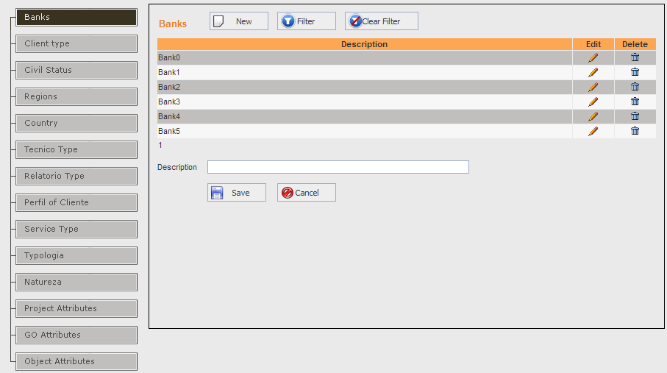

Description:

Functionalities
F01
The Banks grid displays the following columns:
Display Caption | Table Name | Field Name | Width | Translation Key
Description | CH_tblMastBanks | Description | 65%
Edit | Selects the Bank record for editing |  | 10%
Delete | To delete the Bank record |  | 10%

F02 (Add Mode)
Clicking on ‘New’ button, displays a blank text box in the first column of the grid for typing a new Bank description. The two options ‘Save’ and ‘Cancel’, get displayed against the record being added. Selecting ‘Save’ writes the new bank record to the internal table, else selecting ‘Cancel’ ignores the changes done.
F03 (Edit Mode)
Clicking on ‘Edit’ (in the grid against a Bank record), displays a text box in the first column of the grid showing the existing description for the user to change. The two options ‘Save’ and ‘Cancel’, get displayed against the record being edited. Selecting ‘Save’ updates the bank record. Else selecting ‘Cancel’ ignores the changes done.
F04 (Delete Mode)
On clicking Delete (in the grid against a Bank record), the corresponding bank type record is deleted. Before deleting, the user is asked for a confirmation. Only if confirmed ‘Yes’, the record is deleted. If the current bank has any foreign key relationship, then the bank record cannot be deleted.

Physical Table-- Banks
Field Name | Data Type | LEN | M | U | Description | Key | Reference Table | Source Screen/Tab | Source  Lbl. Name
BankId | Int | 4 | Y | Y | Automatically generated id which uniquely identifies a Banks | PK
Description | Varchar | 150 | Y | Y |  |  |  | GUI-CH0105/Banks | Description

Screen Name (GUI Code): GUI-CH0105/CLIENT TYPE

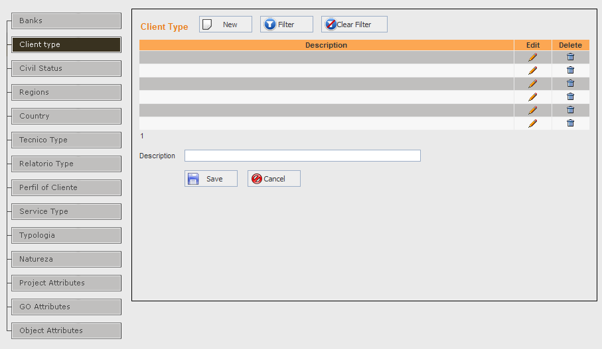

Description:

Functionalities
F01
The Client Type grid displays the following columns:
Display Caption | Table Name | Field Name | Width | Translation Key
Description | CH_tblMastClientType | Description | 65%
Edit | Selects the Client Type record for editing |  | 10%
Delete | To delete the Client Type record |  | 10%

F02 (Add Mode)
Clicking on ‘New’ button, displays a blank text box in the first column of the grid for typing a new Client Type name. The two options ‘Save’ and ‘Cancel’, get displayed against the record being added. Selecting ‘Save’ writes the new Client Type record to the internal table, else selecting ‘Cancel’ ignores the changes done.
F03 (Edit Mode)
Clicking on ‘Edit’ (in the grid against a Client Type record), displays a text box in the first column of the grid showing the existing name for the user to change. The two options ‘Save’ and ‘Cancel’, get displayed against the record being edited. Selecting ‘Save’ updates the Client Type record. Else selecting ‘Cancel’ ignores the changes done.
F04 (Delete Mode)
On clicking Delete (in the grid against a Client Type record), the corresponding Client Type record is deleted. Before deleting, the user is asked for a confirmation. Only if confirmed ‘Yes’, the record is deleted. If the current Client Type has any foreign key relationship, then the Country record cannot be deleted.

Physical Table -- Client Type
Field Name | Data Type | LEN | M | U | Description | Key | Reference Table | Source Screen/Tab | Source  Lbl. Name
ClientTypeId | Int | 4 | Y | Y | Automatically generated id which uniquely identifies a client Type | PK
Description | Varchar | 150 | Y | Y |  |  |  | GUI-CH0105/CLIENT TYPE | Description

Screen Name (GUI Code): GUI-CH0105/CIVILSTATUS
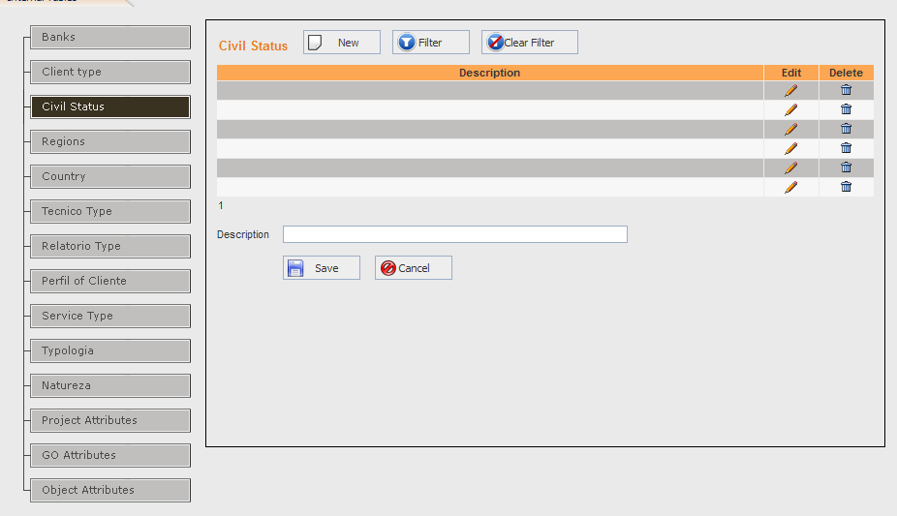

Description:

Functionalities
F01

The Civil Status grid displays the following columns:
Display Caption | Table Name | Field Name | Width | Translation Key
Description | CH_tblMastCivilStatus | Description | 65%
Edit | Selects the Civil Status record for editing |  | 10%
Delete | To delete the Civil Status record |  | 10%

F02 (Add Mode)
Clicking on ‘New’ button, displays a blank text box in the first column of the grid for typing a new Civil status description. The two options ‘Save’ and ‘Cancel’, get displayed against the record being added. Selecting ‘Save’ writes the new civil status record to the internal table, else selecting ‘Cancel’ ignores the changes done.
F03 (Edit Mode)
Clicking on ‘Edit’ (in the grid against a Civil Status record), displays a text box in the first column of the grid showing the existing description for the user to change. The two options ‘Save’ and ‘Cancel’, get displayed against the record being edited. Selecting ‘Save’ updates the Civil Status record. Else selecting ‘Cancel’ ignores the changes done.
F04 (Delete Mode)
On clicking Delete (in the grid against a Civil Status record), the corresponding Civil Status record is deleted. Before deleting, the user is asked for a confirmation. Only if confirmed ‘Yes’, the record is deleted. If the current Civil Status has any foreign key relationship, then the clinical profile record cannot be deleted.

Physical Table -- Civil Status
Field Name | Data Type | LEN | M | U | Description | Key | Reference Table | Source Screen/Tab | Source  Lbl. Name
CivilstatusId | Int | 4 | Y | Y | Automatically generated id which uniquely identifies a civilstatus | PK
Description | Varchar | 150 | Y | Y |  |  |  | GUI-CH0105/CIVIL STATUS | Description

Screen Name (GUI Code): GUI-CH0105/REGIONS
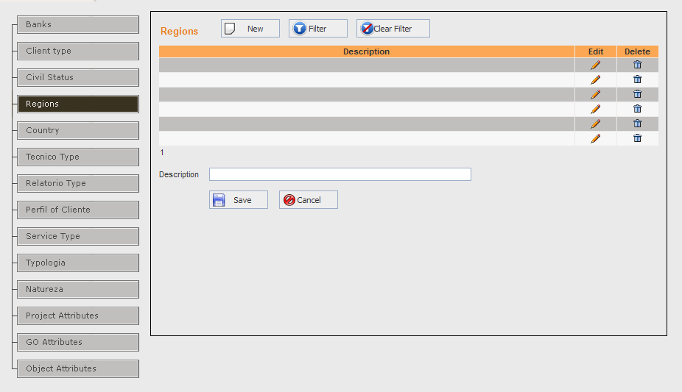

Description:

Functionalities
F01
The Regions grid displays the following columns:
Display Caption | Table Name | Field Name | Width | Translation Key
Description | CH_tblMastRegions | Description | 65%
Edit | Selects the Regions record for editing |  | 10%
Delete | To delete the Regions record |  | 10%

F02 (Add Mode)
Clicking on ‘New’ button, displays a blank text box in the first column of the grid for typing a new Region description. The two options ‘Save’ and ‘Cancel’, get displayed against the record being added. Selecting ‘Save’ writes the new Region record to the internal table, else selecting ‘Cancel’ ignores the changes done.
F03 (Edit Mode)
Clicking on ‘Edit’ (in the grid against a Regions record), displays a text box in the first column of the grid showing the existing description for the user to change. The two options ‘Save’ and ‘Cancel’, get displayed against the record being edited. Selecting ‘Save’ updates the Regions record. Else selecting ‘Cancel’ ignores the changes done.
F04 (Delete Mode)
On clicking Delete (in the grid against a Regions record), the corresponding Regions record is deleted. Before deleting, the user is asked for a confirmation. Only if confirmed ‘Yes’, the record is deleted. If the current Regions has any foreign key relationship, then the Regions record cannot be deleted.

Physical Table -- Regions
Field Name | Data Type | LEN | M | U | Description | Key | Reference Table | Source Screen/Tab | Source  Lbl. Name
RegionId | Int | 4 | Y | Y | Automatically generated id which uniquely identifies a Region | PK
Description | Varchar | 150 | Y | Y |  |  |  | GUI-CH0105/Regions | Description

Screen Name (GUI Code): GUI-CH0105/COUNTRY
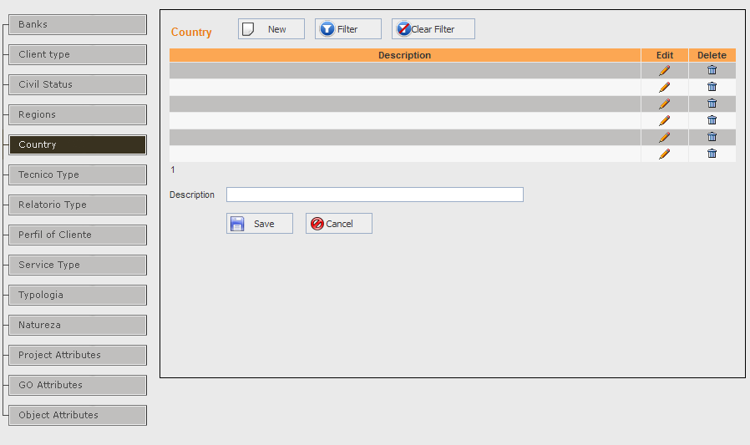

Description:
Functionalities
F01
The Country grid displays the following columns:

Display Caption | Table Name | Field Name | Width | Translation Key
Description | CH_tblMastCountry | Description | 65%
Edit | Selects the Country record for editing |  | 10%
Delete | To delete the Country record |  | 10%

F02 (Add Mode)
Clicking on ‘New’ button, displays a blank text box in the first column of the grid for typing a new Country name. The two options ‘Save’ and ‘Cancel’, get displayed against the record being added. Selecting ‘Save’ writes the new Country and Short Name record to the internal table, else selecting ‘Cancel’ ignores the changes done.
F03 (Edit Mode)
Clicking on ‘Edit’ (in the grid against a Country record), displays a text box in the first column of the grid showing the existing name for the user to change. The two options ‘Save’ and ‘Cancel’, get displayed against the record being edited. Selecting ‘Save’ updates the Country record. Else selecting ‘Cancel’ ignores the changes done.
F04 (Delete Mode)
On clicking Delete (in the grid against a Country record), the corresponding Country record is deleted. Before deleting, the user is asked for a confirmation. Only if confirmed ‘Yes’, the record is deleted. If the current country has any foreign key relationship, then the Country record cannot be deleted.

Physical Table -- Country
Field Name | Data Type | LEN | M | U | Description | Key | Reference Table | Source Screen/Tab | Source  Lbl. Name
countryId | Int | 4 | Y | Y | Automatically generated id which uniquely identifies a country | PK
Description | Varchar | 150 | Y | Y |  |  |  | GUI-CH0105/COUNTRY | Description

Screen Name (GUI Code): GUI-CH0105/TECNICO TYPE
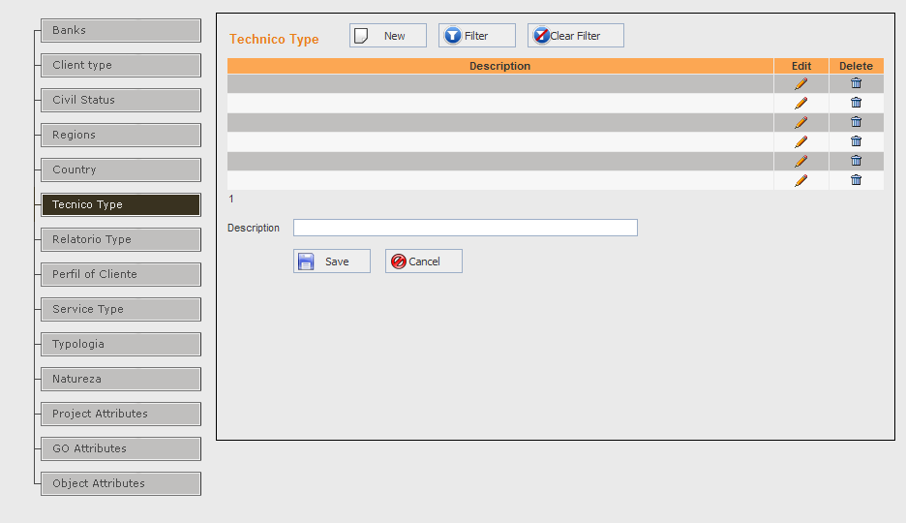

Description:

Functionalities
F01
The Tecnico Type grid displays the following columns:
Display Caption | Table Name | Field Name | Width | Translation Key
Description | CH_tblMastTechnicoType | Description | 65%
Edit | Selects the Techico Type record for editing |  | 10%
Delete | To delete the Techico Type record |  | 10%

F02 (Add Mode)
Clicking on ‘New’ button, displays a blank text box in the first column of the grid for typing a new Techico Type description. The two options ‘Save’ and ‘Cancel’, get displayed against the record being added. Selecting ‘Save’ writes the new Techico Type record to the internal table, else selecting ‘Cancel’ ignores the changes done.
F03 (Edit Mode)
Clicking on ‘Edit’ (in the grid against a Techico Type record), displays a text box in the first column of the grid showing the existing description for the user to change. The two options ‘Save’ and ‘Cancel’, get displayed against the record being edited. Selecting ‘Save’ updates the Techico Type record. Else selecting ‘Cancel’ ignores the changes done.
F04 (Delete Mode)
On clicking Delete (in the grid against a Techico Type record), the corresponding Techico Type record is deleted. Before deleting, the user is asked for a confirmation. Only if confirmed ‘Yes’, the record is deleted. If the current Techico Type has any foreign key relationship, then the period of visit record cannot be deleted.

Physical Table -- Tecnico Type
Field Name | Data Type | LEN | M | U | Description | Key | Reference Table | Source Screen/Tab | Source  Lbl. Name
TecnicoTypeId | Int | 4 | Y | Y | Automatically generated id which uniquely identifies a TecnicoType | PK
Description | Varchar | 150 | Y | Y |  |  |  | GUI-CH0105/TECNICOTYPE | Description

Screen Name (GUI Code): GUI-CH0105/RELATORIO TYPE
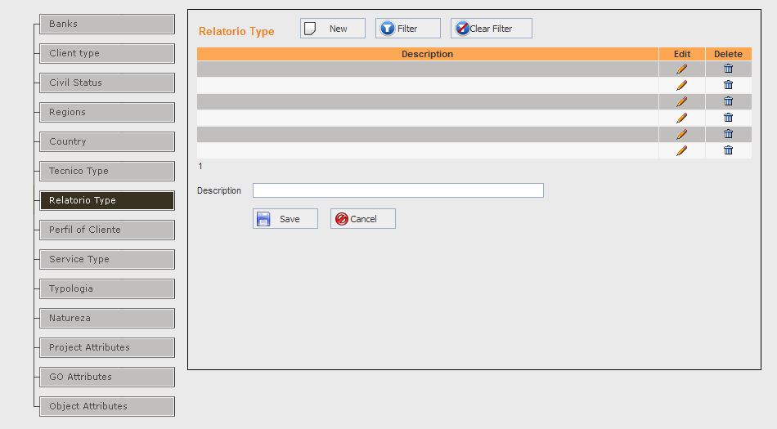

Description:

Functionalities
F01
The Relatorio Type grid displays the following columns:
Display Caption | Table Name | Field Name | Width | Translation Key
Description | CH_tblMastRelatorioType | Description | 65%
Edit | Selects the Relatorio Type record for editing |  | 10%
Delete | To delete the Relatorio Type record |  | 10%

F02 (Add Mode)
Clicking on ‘New’ button, displays a blank text box in the first column of the grid for typing a new Relatorio Type description. The two options ‘Save’ and ‘Cancel’, get displayed against the record being added. Selecting ‘Save’ writes the new Relatorio Type record to the internal table, else selecting ‘Cancel’ ignores the changes done.
F03 (Edit Mode)
Clicking on ‘Edit’ (in the grid against a Relatorio Type record), displays a text box in the first column of the grid showing the existing description for the user to change. The two options ‘Save’ and ‘Cancel’, get displayed against the record being edited. Selecting ‘Save’ updates the Relatorio Type record. Else selecting ‘Cancel’ ignores the changes done.
F04 (Delete Mode)
On clicking Delete (in the grid against a Relatorio Type record), the corresponding Relatorio Type record is deleted. Before deleting, the user is asked for a confirmation. Only if confirmed ‘Yes’, the record is deleted. If the current Relatorio Type has any foreign key relationship, then the Relatorio Type record cannot be deleted.

Physical Table -- Relatorio Type
Field Name | Data Type | LEN | M | U | Description | Key | Reference Table | Source Screen/Tab | Source  Lbl. Name
RelatoriotypeId | Int | 4 | Y | Y | Automatically generated id which uniquely identifies a Relatorio Type | PK
Description | Varchar | 150 | Y | Y |  |  |  | GUI-CH0105/RELATORIO | Description

Screen Name (GUI Code): GUI-CH0105/PERFIL OF CLIENTE
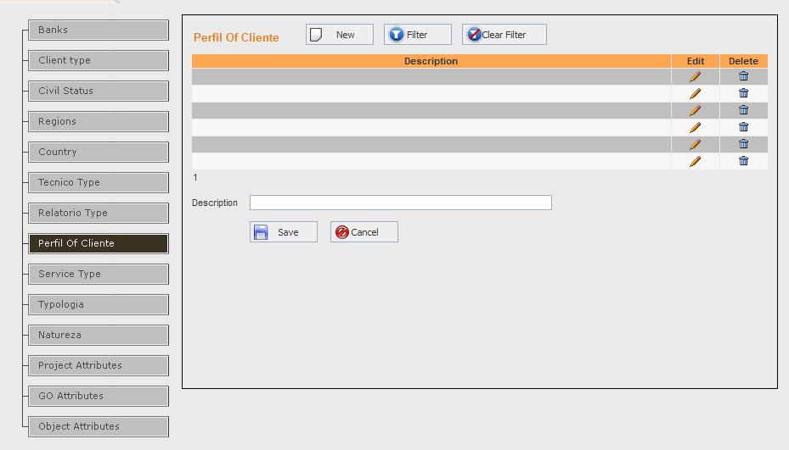

Description:

Functionalities
F01
The Perfil OF Cliente grid displays the following columns:
Display Caption | Table Name | Field Name | Width | Translation Key
Description | CH_tblMastPerfilOfClient | Description | 65%
Edit | Selects the Perfil OF Cliente record for editing |  | 10%
Delete | To delete the Perfil OF Cliente record |  | 10%

F02 (Add Mode)
Clicking on ‘New’ button, displays a blank text box in the first column of the grid for typing a new Perfil OF Cliente description. The two options ‘Save’ and ‘Cancel’, get displayed against the record being added. Selecting ‘Save’ writes the new Perfil OF Cliente record to the internal table, else selecting ‘Cancel’ ignores the changes done.
F03 (Edit Mode)
Clicking on ‘Edit’ (in the grid against a Perfil OF Cliente record), displays a text box in the first column of the grid showing the existing description for the user to change. The two options ‘Save’ and ‘Cancel’, get displayed against the record being edited. Selecting ‘Save’ updates the Perfil OF Cliente record. Else selecting ‘Cancel’ ignores the changes done.
F04 (Delete Mode)
On clicking Delete (in the grid against a Perfil OF Cliente record), the corresponding Perfil OF Cliente record is deleted. Before deleting, the user is asked for a confirmation. Only if confirmed ‘Yes’, the record is deleted. If the current Perfil OF Cliente has any foreign key relationship, then the Perfil OF Cliente record cannot be deleted.

Physical Table -- Perfil of Cliente
Field Name | Data Type | LEN | M | U | Description | Key | Reference Table | Source Screen/Tab | Source  Lbl. Name
PerfilOfClienteId | Int | 4 | Y | Y | Automatically generated id which uniquely identifies a PerfilOfCliente | PK
Description | Varchar | 150 | Y | Y |  |  |  | GUI-CH0105/PERFILOFCLIENTE | Description

Screen Name (GUI Code): GUI-CH0105/SERVICE TYPE
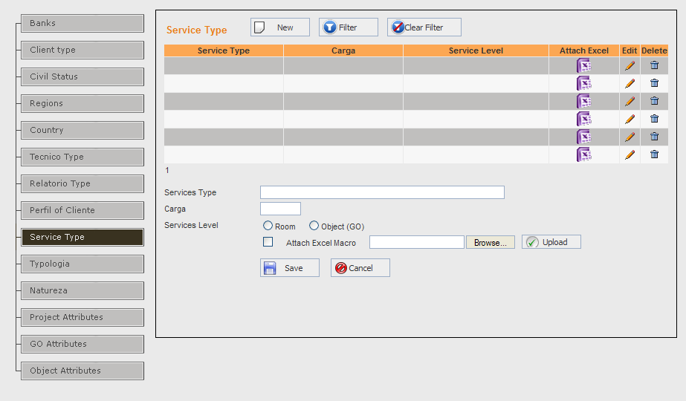

Description:

Functionalities
F01
The Service Type grid displays the following columns:
Display Caption | Table Name | Field Name | Width | Translation Key
Description | CH_tblMastserviceType | Description | 25%
Carga | CH_tblMastserviceType | Carga | 25%
ServiceLevel | CH_tblMastserviceType | ServiceLevel | 25%
Attach Excel | CH_tblMastserviceType | AttachExcel | 10%
Edit | Selects the Service Type record for editing |  | 5%
Delete | To delete the Service Type record |  | 5%

F02 (Add Mode)
Clicking on ‘New’ button, displays a blank text box in the first column of the grid for typing a new Service Type description, the textbox in the second column for carga, the textbox in the third column for service level and the fourth column for attach excel. The two options ‘Save’ and ‘Cancel’, get displayed against the record being added. Selecting ‘Save’ writes the new Service Type record to the internal table, else selecting ‘Cancel’ ignores the changes done.
F03 (Edit Mode)
Clicking on ‘Edit’ (in the grid against a Service Type record), displays a text box in the first column of the grid showing the existing description, carga, ServiceLevel, Attachexcel for the user to change. The two options ‘Save’ and ‘Cancel’, get displayed against the record being edited. Selecting ‘Save’ updates the Service Type record. Else selecting ‘Cancel’ ignores the changes done.
F04 (Delete Mode)
On clicking Delete (in the grid against a Service Type record), the corresponding Service Type record is deleted. Before deleting, the user is asked for a confirmation. Only if confirmed ‘Yes’, the record is deleted. If the current Service Type has any foreign key relationship, then the Service Type record cannot be deleted.

Physical Table -- Service Type
Field Name | Data Type | LEN | M | U | Description | Key | Reference Table | Source Screen/Tab | Source  Lbl. Name
ServiceTypeId | Int | 4 | Y | Y | Automatically generated id which uniquely identifies a ServiceType | PK
Carga | Int | 4 | Y | Y |  |  |  | GUI-CH0105/SERVICETYPE | Description
ServiceLevel | Bit |  |  |  |  |  |  | GUI-CH0105/SERVICETYPE | Service Level

Screen Name (GUI Code): GUI-CH0105/TYPOLOGIA
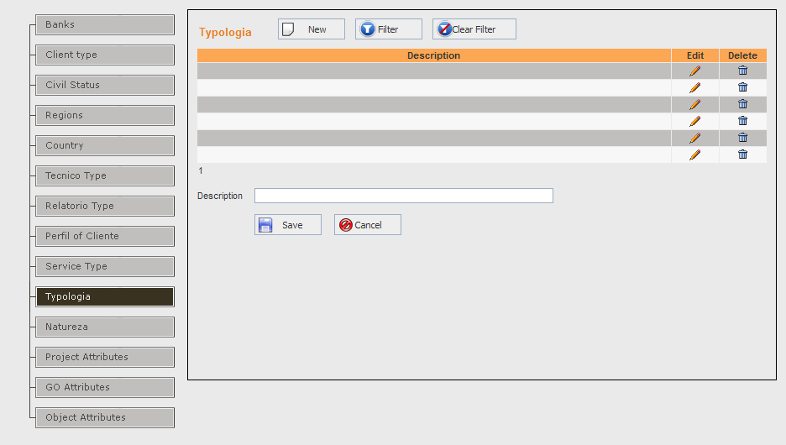

Description:

Functionalities
F01
The Typologia grid displays the following columns:
Display Caption | Table Name | Field Name | Width | Translation Key
Description | CH_tblMastTypologia | Description | 80%
Edit | Selects the Typologia record for editing |  | 10%
Delete | To delete the Typologia record |  | 10%

F02 (Add Mode)
Clicking on ‘New’ button, displays a blank text box in the first column of the grid for typing a new Typologia description. The two options ‘Save’ and ‘Cancel’, get displayed against the record being added. Selecting ‘Save’ writes the new Typologia record to the internal table, else selecting ‘Cancel’ ignores the changes done.
F03 (Edit Mode)
Clicking on ‘Edit’ (in the grid against a Typologia record), displays a text box in the first column of the grid showing the existing description for the user to change. The two options ‘Save’ and ‘Cancel’, get displayed against the record being edited. Selecting ‘Save’ updates the Typologia record. Else selecting ‘Cancel’ ignores the changes done.
F04 (Delete Mode)
On clicking Delete (in the grid against a Typologia record), the corresponding Typologia record is deleted. Before deleting, the user is asked for a confirmation. Only if confirmed ‘Yes’, the record is deleted. If the current Typologia has any foreign key relationship, then the Typologia record cannot be deleted.

Physical Table -- Typologia
Field Name | Data Type | LEN | M | U | Description | Key | Reference Table | Source Screen/Tab | Source  Lbl. Name
TypologiaId | Int | 4 | Y | Y | Automatically generated id which uniquely identifies a Typologia | PK
Description | Varchar | 150 | Y | Y |  |  |  | GUI-CH0105/TYPOLOGIA | Description

Screen Name (GUI Code): GUI-CH0105/NATUREZA
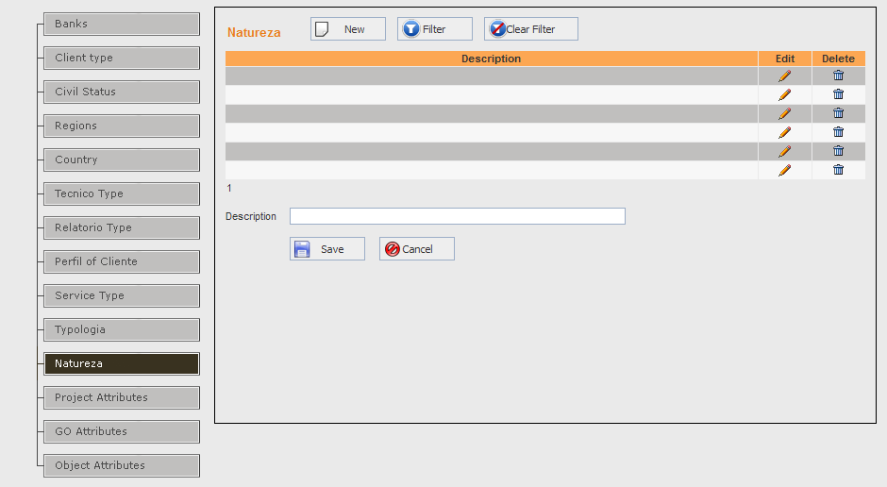

Description:

Functionalities
F01
The Natureza grid displays the following columns:

Display Caption | Table Name | Field Name | Width | Translation Key
Description | CH_tblMastNatureza | Description | 65%
Edit | Selects the Natureza record for editing |  | 10%
Delete | To delete the Natureza record |  | 10%

F02 (Add Mode)
Clicking on ‘New’ button, displays a blank text box in the first column of the grid for typing a new Natureza. The two options ‘Save’ and ‘Cancel’, get displayed against the record being added. Selecting ‘Save’ writes the new Natureza record to the internal table, else selecting ‘Cancel’ ignores the changes done.
F03 (Edit Mode)
Clicking on ‘Edit’ (in the grid against an Natureza record), displays a text box in the first column of the grid showing the existing description. The two options ‘Save’ and ‘Cancel’, get displayed against the record being edited. Selecting ‘Save’ updates the Natureza record, else selecting ‘Cancel’ ignores the changes done.

F04 (Delete Mode)
On clicking Delete (in the grid against an Natureza record), the corresponding Natureza record is deleted. Before deleting, the user is asked for a confirmation. Only if confirmed ‘Yes’, the record is deleted. If the current Natureza has any foreign key relationship, then the Natureza record cannot be deleted.

Physical Table -- Natureza
Field Name | Data Type | LEN | M | U | Description | Key | Reference Table | Source Screen/Tab | Source  Lbl. Name
NaturezaId | Int | 4 | Y | Y | Automatically generated id which uniquely identifies a Natureza | PK
Description | Varchar | 150 | Y | Y |  |  |  | GUI-CH0105/NATUREZA | Description

Screen Name (GUI Code): GUI-CH0105/PROJECT ATTRIBUTES
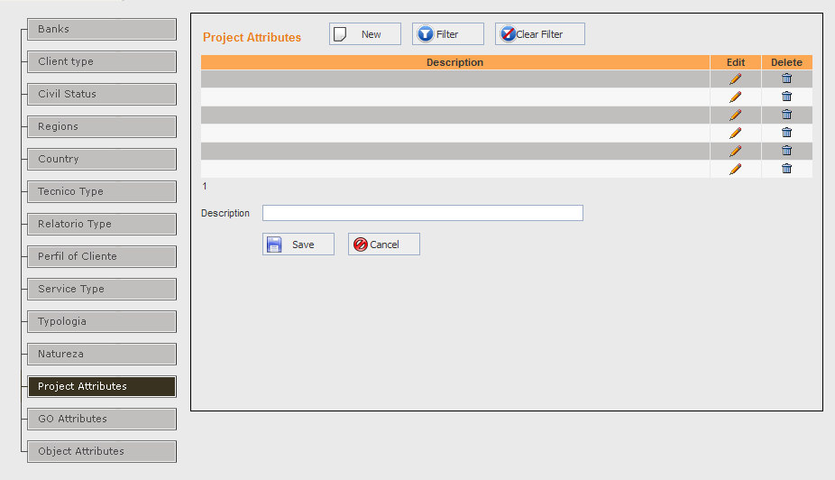

Description:

Functionalities
F01
The Project Attributes grid displays the following columns:
Display Caption | Table Name | Field Name | Width | Translation Key
Description | CH_tblMastProjectAttributes | Description | 65%
Edit | Selects the Project Attributes record for editing |  | 10%
Delete | To delete the Project Attributes record |  | 10%

F02 (Add Mode)
Clicking on ‘New’ button, displays a blank text box in the first column of the grid for typing a new Project Attributes Description. The two options ‘Save’ and ‘Cancel’, get displayed against the record being added. Selecting ‘Save’ writes the new Project Attributes record to the internal table, else selecting ‘Cancel’ ignores the changes done.
F03 (Edit Mode)
Clicking on ‘Edit’ (in the grid against a Project Attributes record), displays a text box in the first column of the grid showing the existing description for the user to change. The two options ‘Save’ and ‘Cancel’, get displayed against the record being edited. Selecting ‘Save’ updates the Project Attributes record, else selecting ‘Cancel’ ignores the changes done.
F04 (Delete Mode)
On clicking Delete (in the grid against a Project Attributes record), the corresponding Project Attributes record is deleted. Before deleting, the user is asked for a confirmation. Only if confirmed ‘Yes’, the record is deleted. If the current Project Attributes has any foreign key relationship, then the Project Attributes record cannot be deleted.

Physical Table -- ProjectAttributes
Field Name | Data Type | LEN | M | U | Description | Key | Reference Table | Source Screen/Tab | Source  Lbl. Name
ProjectAttributeId | Int | 4 | Y | Y | Automatically generated id which uniquely identifies a ProjectAttribute | PK
Description | Varchar | 150 | Y | Y |  |  |  | GUI-CH0105/PROJECTATTRIBUTE | Description

Screen Name (GUI Code): GUI-CH0105/GO ATTRIBUTES
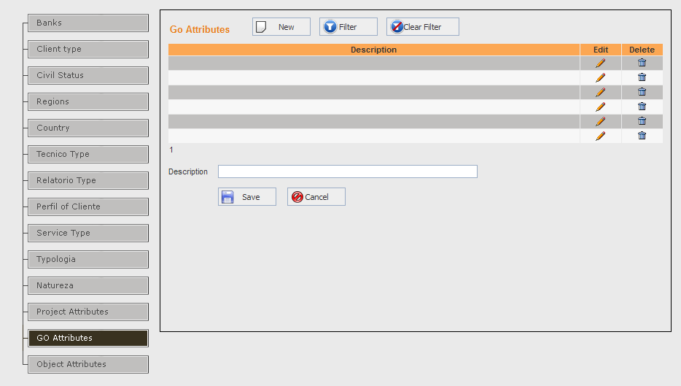

Description:

Functionalities
F01
The Go attributes grid displays the following columns:
Display Caption | Table Name | Field Name | Width | Translation Key
Description | CH_tblMastGoAttributes | Description | 65%
Edit | Selects the GO Attributes record for editing |  | 10%
Delete | To delete the GO Attributes record |  | 10%
F02 (Add Mode)
Clicking on ‘New’ button, displays a blank text box in the first column of the grid for typing a new GO Attributes. The two options ‘Save’ and ‘Cancel’, get displayed against the record being added. Selecting ‘Save’ writes the new GO Attributes record to the internal table, else selecting ‘Cancel’ ignores the changes done.
F03 (Edit Mode)
Clicking on ‘Edit’ (in the grid against a GO Attributes record), displays a text box in the first column of the grid showing the existing name for the user to change. The two options ‘Save’ and ‘Cancel’, get displayed against the record being edited. Selecting ‘Save’ updates the GO Attributes record, else selecting ‘Cancel’ ignores the changes done.
F04 (Delete Mode)
On clicking Delete (in the grid against a GO Attributes record), the corresponding GO Attributes record is deleted. Before deleting, the user is asked for a confirmation. Only if confirmed ‘Yes’, the record is deleted. If the current GO Attributes has any foreign key relationship, then the GO Attributes record cannot be deleted.

Physical Table -- GoAttributes
Field Name | Data Type | LEN | M | U | Description | Key | Reference Table | Source Screen/Tab | Source  Lbl. Name
GoAttributeId | Int | 4 | Y | Y | Automatically generated id which uniquely identifies a GoAttributeid | PK
Description | Varchar | 150 | Y | Y |  |  |  | GUI-CH0105/GOATTRIBUTE | Description

Screen Name (GUI Code): GUI-CH0105/OBJECT ATTRIBUTES
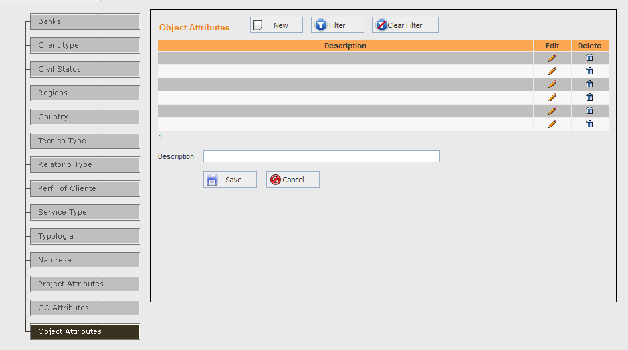

Description:

Functionalities
F01
The ObjectAttributes grid displays the following columns:
Display Caption | Table Name | Field Name | Width | Translation Key
Description | CH_tblMastObjectAttributes | Description | 65%
Edit | Selects the ObjectAttributes record for editing |  | 10%
Delete | To delete the ObjectAttributes record |  | 10%

F02 (Add Mode)
Clicking on ‘New’ button, displays a blank text box in the first column of the grid for selecting a new ObjectAttributes. The two options ‘Save’ and ‘Cancel’, get displayed against the record being added. Selecting ‘Save’ writes the ObjectAttributes to the internal table, else selecting ‘Cancel’ ignores the changes done.
F03 (Edit Mode)
Clicking on ‘Edit’ (in the grid against a ObjectAttributes record), displays a text box in the first column of the grid showing the existing name for the user to change. The two options ‘Save’ and ‘Cancel’, get displayed against the record being edited. Selecting ‘Save’ updates the ObjectAttributes record, else selecting ‘Cancel’ ignores the changes done.
F04 (Delete Mode)
On clicking Delete (in the grid against a ObjectAttributes record), the corresponding ObjectAttributes record is deleted. Before deleting, the user is asked for a confirmation. Only if confirmed ‘Yes’, the record is deleted. If the current ObjectAttributes has any foreign key relationship, then the ObjectAttributes record cannot be deleted.

Physical Table -- ObjectAttribute
Field Name | Data Type | LEN | M | U | Description | Key | Reference Table | Source Screen/Tab | Source  Lbl. Name
ObjectAttributeId | Int | 4 | Y | Y | Automatically generated id which uniquely identifies a ObjectAttribute | PK
Description | Varchar | 150 | Y | Y |  |  |  | GUI-CH0105/OBJECTATTRIBUTE | Description

