INTERNAL MESSAGING

Document Number | 1.0
Softcopy Name | CH0205_InternalMessaging.docx
Last Saved | February 05th, 2009
Document Classification | SRS of CheckHouse
Prepared By | Balaji.J
Reviewed By

COPYRIGHT NOTICE
Copyright © by SHLOK Information Systems India Private Limited.
All rights reserved. This material is confidential and proprietary to SHLOK Information Systems India Private Limited. and no part of this material should be reproduced, published in any form by any means, electronic or mechanical including photocopy or any information storage or retrieval system nor should the material be disclosed to third parties without the express written authorization of SHLOK Information Systems India Private Limited.

Internal Messaging 3
Module/Screen 3
Purpose: 3
Description: 3
The second tab ‘Send messages’ is used by the member of the system to send messages to one or more co-members of the system. 3
The third tab ‘Sent messages’ is the place which lists the messages that have been sent by the login user to other co-members of the system. 3
Screen Shots 4
Screen Name (GUI Code): GUI-CH0205/INBOX 4
Screen Shots 6
Screen Name (GUI Code): GUI-CH0205/SNDMSG 6
Screen Name (GUI Code): GUI-CH0205/SNTMSG 7
Logical field: 9
GUI-CH0205/SNDMSG 9
Physical table: 10
Table inserted: 10
CH_tblTranInternalMessages 10
CH_tblTranMessageGroup 10
Screen Shots 10
Screen Name 10
GUI-CH0205/SNDMSG 10
CH_tblTranInternalMessages 10
GUI-CH0205/INBOX 10
CH_tblTranInternalMessages 10
GUI-CH0205/SNDMSG 10
CH_tblTranMessageGroup 10
GUI-CH0205/SNTMSG 10
CH_tblTranMessageGroup 10

Internal Messaging

Module/Screen

Module | Transaction – Internal Messaging
GUI Code | CH0205
GUI Name | Internal Messaging

Purpose:

The interface is for the maintenance of internal messaging that is passed in between the members of the system.

Description:

The screen can be split up into three parts as represented by the tabs for explaining the functionality.

The first tab ‘Inbox’, as the name suggests acts as the place to store all the messages received by the login user from the various member of the system. The user can view the messages which until opened are marked as unread. Once the user opens a message it is marked as read. The user has the filter options to view the list of unread messages, read messages etc. Similarly the user has the option to select all read / unread messages and delete them.

The second tab ‘Send messages’ is used by the member of the system to send messages to one or more co-members of the system.

The third tab ‘Sent messages’ is the place which lists the messages that have been sent by the login user to other co-members of the system.

Screen Shots

Screen Name (GUI Code): GUI-CH0205/INBOX
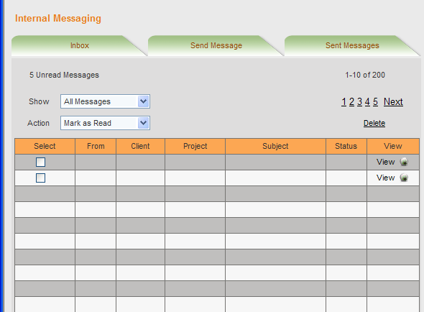
- Legend
On the top it shows the number of messages so far unread by the user as well as the total number of messages received by the user so far. 10 messages are displayed per page.

- Inbox list
The Inbox displays the messages for which ‘IsReceiverDelete’ is true and Groupid contains the EmployeeId which is Login user id, in the descending order of date with the latest message on the top. The list displays the 1st page of messages and the user has the option of navigating to the next 4 pages and then, the ‘Next’ link to show the next set of 5 pages. This goes on until the list of messages get depleted.

- Show Filter
The user has the option to filter the list of messages, which could be either Read or Unread or All messages as available in the combo box for ‘Show’.

- Action control

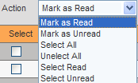

As the list suggests 6 actions are possible.
- ‘Mark as Read’
This action marks all the selected messages as read.
- ‘Mark as Unread’
This action marks all the selected messages as unread.
- ‘Select All’
This action selects all messages.
- ‘Unselect All’
This action unselects all messages.
- ‘Select Read’
This action selects all read messages.
- ‘Select Unread’
This action selects all unread messages.

- Delete link
The delete link over the list deletes all messages that are selected in the list.

- View button
View button at the end of each message is used to open the message as a popup to be read by the user.

The inbox grid displays the following columns:
Display Caption | Table Name | Field Name | Width | Translation Key
Select |  |  | 5%
From | CH_tblEmployees | EmployeeName | 15%
Client | CH_tblClients | ClientName | 20%
Project | CH_tblProjects | ProjectName | 20%
Subject | CH_tblInternalMessages | Subject | 20%
Status | CH_tblInternalMessages | Status | 15%
View | Displays the message in a popup screen |  | 5%

Screen Shots

Screen Name (GUI Code): GUI-CH0205/SNDMSG

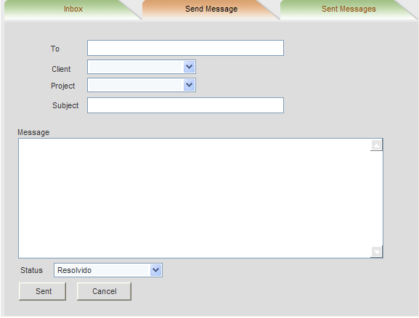
F02
Send message
- Send – Confirms that the message is ok and can be sent. Saves the record in table for Internal messages and clears the screen.
- Cancel - Cancels the send and clears the screen.

Screen Name (GUI Code): GUI-CH0205/SNTMSG

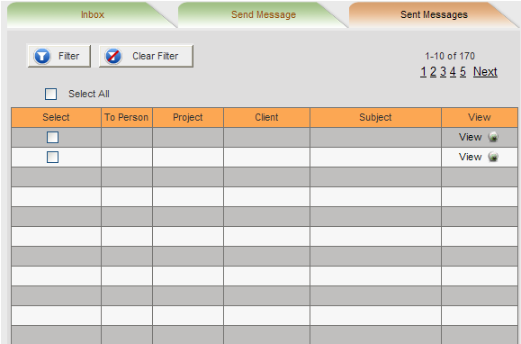
Please discuss with me before you start development on this screen as the filter condition screen needs to be completely redesigned. Also to be considered is the button adjacent to each message to view the status of the message with each destination user.
F01
The Filter condition to list the sent messages could be specified, based on the condition the messages are displayed below.

FO2
The Filter condition can be cleared by clicking Clear filter button all the messages set are displayed below.

- Legend
On the top it shows the number of messages so far unread by the user as well as the total number of messages received by the user so far. 10 messages are displayed per page.

- Sent messages list
The Sent messages list displays the messages for which ‘IsSenderDelete’ is true and SenderId is Login user id in the descending order of date with the latest message on the top. The list displays the 1st page of messages and the user has the option of navigating to the next 4 pages and then, the ‘Next’ link to show the next set of 5 pages. This goes on until the list of messages get depleted.
- Select all link
The Select all link over the list selects all sent messages that are in the list.

- Delete link
The delete link over the list deletes all messages that are selected in the list.

- View button
View button at the end of each message is used to open the message as a popup to be read by the user.

Logical field:

GUI-CH0205/SNDMSG

Logical Field | Key  (PK/FK/UK) | FKey Table Name | Description | Tab | Control Type | Enable / Disable | Default | On Change | Lookup/List | When Clause | Verify on OK
To |  |  | Each user is separated by ; | 0 | Text Box |  |  |  |  |  | M, C(255)
Client | FK | tblMastClients |  | 1 | Combo Box |  |  |  | Table: tblMastClients  Key:Clientid |  | M
Project | FK |  |  | 2 | Combo Box |  |  |  | Table: tblMastProjects  Key:Projectid  Filter:ClientId=Client selecte
Subject |  |  |  | 3 | Text Box |  |  |  |  |  | M, C(50)
Message |  |  |  | 4 | TextBox |  |  |  |  |  | M,C(2000)
Status |  |  |  | 5 | Combo Box |  |  |  | Resolvido  Por Resolver  N/A Appilcavel |  | M

Physical table:

Table inserted:

CH_tblTranInternalMessages
Field Name | Data Type | LEN | M | U | Description | Key | Reference Table | Source Screen/Tab | Source  Lbl. Name
MessageID | Int | 4 | Y | Y | Automatic generation | PK
GroupId | Int | 4 | Y |  | Group for the sent message | FK | CH_tblTranMessageGroup | CH0205/SNDMSG | To
ClientId | Int | 4 | Y |  |  | FK | CH_tblMastClient | CH0205/SNDMSG | Client
ProjectId | Int | 4 |  |  |  | FK | CH_tblMastProject | CH0205/SNDMSG | Project
Subject | Varchar | 50 | Y |  |  |  |  | CH0205/SNDMSG | Subject
Message | Varchar | 2000 | Y |  |  |  |  | CH0205/SNDMSG | Message
MessageTime | Date/Time |  | Y |  | The time when the message was sent
SenderId | Int | 4 | Y |  | Logged in user | FK | CH_tblMastEmployees
IsSenderDelete | bit |  |  |  | When sender deletes the message

CH_tblTranMessageGroup
Field Name | Data Type | LEN | M | U | Description | Key | Reference Table | Source Screen/Tab | Source  Lbl. Name
GroupId | Int | 4 |  |  | Group for the sent message | PK
MessageId | Int | 4 |  |  | Message record | FK | CH_tblTranInternalMessages

CH_tblTranGroupMembers
Field Name | Data Type | LEN | M | U | Description | Key | Reference Table | Source Screen/Tab | Source  Lbl. Name
GroupMemberId | Int | 4 |  |  | Group Members | PK
GroupId | Int | 4 |  |  | Group for the sent message | FK | CH_tblTranMessageGroup
EmployeeId | Int | 4 |  |  | For each user in To box | FK | CH_tblMastEmployees | CH0205/SNDMSG | To
MessageStatus | varchar | 1 | Y |  |  |  |  | CH0205/SNDMSG | Status
IsMessageRead | Bit
IsReceiverDelete | Bit |  |  |  | When receiver deletes message

Screen Shots
Screen Name | Table Name | Type of effect
GUI-CH0205/SNDMSG | CH_tblTranInternalMessages | Pressing SEND button  If ‘Send’ button is clicked a record is added in the Internal messages table with the values entered.
GUI-CH0205/INBOX | CH_tblTranInternalMessages | Pressing Delete button  Update IsSenderDelete as True.
GUI-CH0205/SNDMSG | CH_tblTranMessageGroup | Pressing SEND button  If ‘Send’ button is clicked a record is added in the Internal messages table with the values entered.
GUI-CH0205/SNTMSG | CH_tblTranMessageGroup | Pressing Delete button  Update IsReceiverDelete as True.

